Early Iowa Lumber Industry
William J. Young was born in Ireland in 1827 and emigrated to the United States in 1846. As a young man, he worked as a railroad contractor, and it was while he was working for the railroads that he met some wealthy men in Cincinnati who owned the Ohio Mill Company. They wanted to open a lumber yard in Clinton, Iowa and hired Young as an agent to run it. Young believed he would have more opportunities in the lumber business than he would working for the railroad, so he agreed to move west to Iowa. Eventually Young became a partner in the business, and it was renamed the W. J. Young Lumber Company.
The success of the company was due in part to its ability to respond to the growing demand for lumber to build homes, barns and businesses as Iowa and neighboring states filled with settlers following the Civil War. The expansion of the railroad also contributed to the success of the company in a couple of different ways. The construction of the railroads required a large amount of lumber, especially to build bridges, and the railroads provided a way to transport lumber to other markets. To meet growing demands, Young doubled his capacity in 1867 with the construction of a second sawmill. This second sawmill was said to have the largest production capacity of any mill along the Mississippi River.
Another mill owner along the Mississippi River was Ernst Heinrich Struve. Struve emigrated from Holstein, Germany to the United States in 1849. His ship landed in New Orleans, where a fellow German recommended that he settle in Iowa due to its fertile land. During his early years in Iowa, Struve witnessed rapid changes and population growth. He mentioned in a letter to his parents in 1849 that Davenport already had a population of 2,000 people despite having been settled only a few years earlier. He purchased land with his brother near Davenport in the early 1850s, which they sold three years later for a good profit. He credited the increase in land prices to the influx of immigrants arriving in Iowa as well as the completion of the railroad between Iowa and New York. Struve experienced continued good fortune, and in 1869 he became part owner of Elk River Mill in Hauntown, Iowa. The mill was eventually passed to his son, William, and then to his grandson, Leslie, who operated it as a sawmill until the 1980s.

Sources:
Sieber, George Wesley. “Sawmilling On the Mississippi: The W. J. Young Lumber Company, 1858-1900.” PhD Dissertation, University of Iowa, 1960.
“Deutschland nach Amerika: The Struve Story.” Compiled by Evelyn Baasch Wieck, 2002. Collection of The Sawmill Museum.
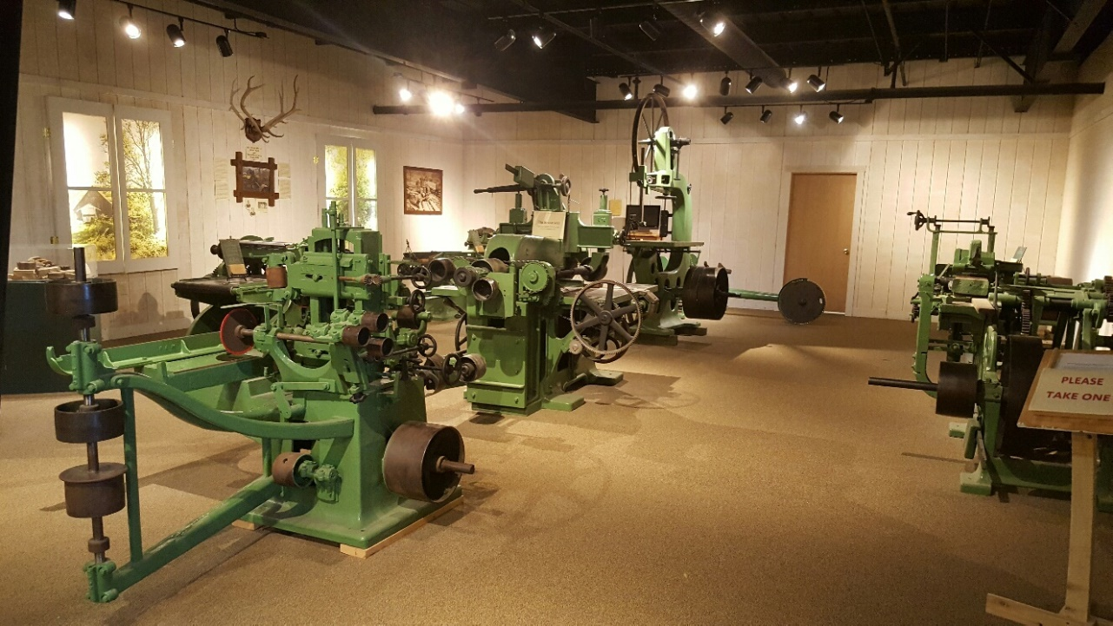
Leslie Struve Mill Equipment at The Sawmill Museum

Ernst Heinrich Struve with his wife, Catharina Schnoor Struve

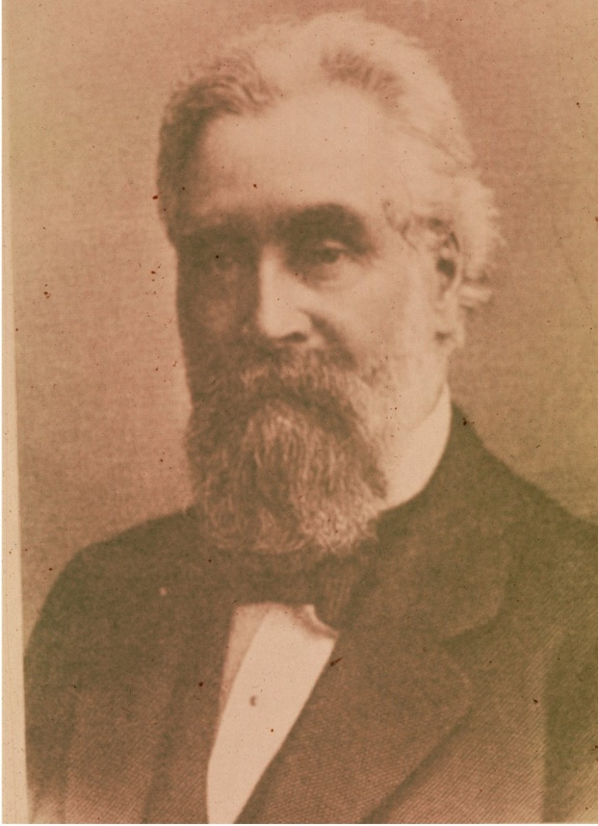
William J. Young

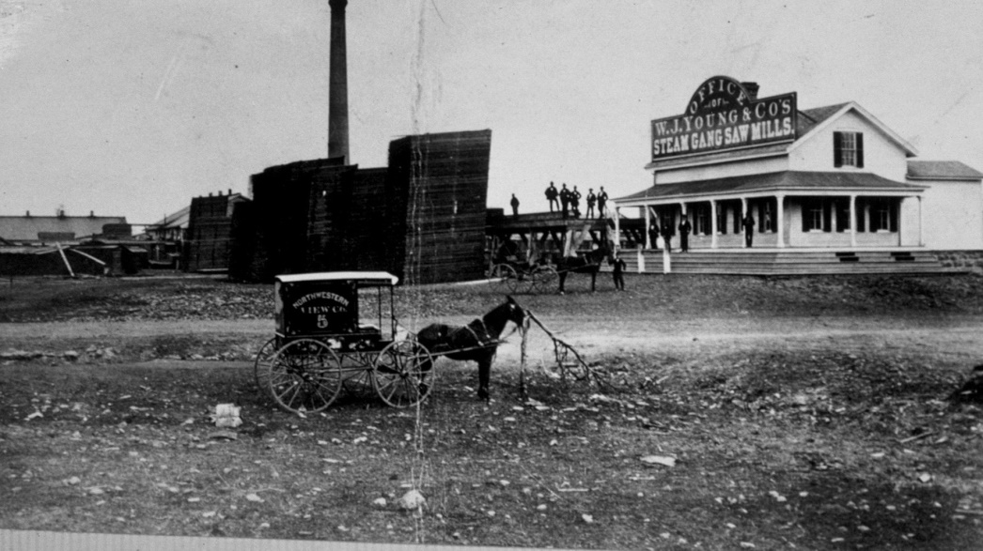
Office of W. J. Young’s Steam Gang Saw Mills

