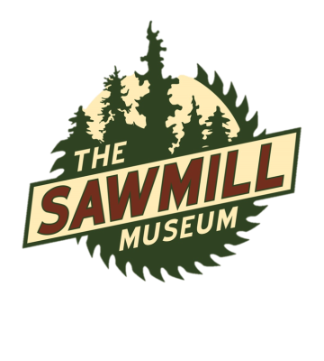
Field Trip Bus Scholarship Program
The Sawmill Museum is committed to educating area students about the American lumber saga and Clinton’s rich connections to this history. An anonymous donor, knowing the impact every dollar makes in education, created a busing scholarship to help defray transportation costs. To apply for a scholarship, please fill this form out and mail to The Sawmill Museum PO Box 3191 Clinton, IA 52732. Awards range from $50 to a maximum of $100. If you come on multiple days, please fill out multiple forms
Field Trip Bus Scholarship Reimbursement Request Form
Date of Field Trip:
School:
Teacher(s):
Number of buses: Number of Classes: Number of students:
Contact information (name, phone, email):
Make reimbursement check out to:
Attention:
Mail completed form to The Sawmill Museum, PO Box 3191, Clinton, Iowa 52732
------------------------------------------------------------------------------------------------------------------------------------------
Internal Use Only
Round trip miles, school to museum _____________
Amount awarded: $________________
Date Received: ___________________
Date Reimbursed: ________________

