Hours:  Tuesday-Saturday 10am-6pm  Sunday 1pm-5pm  Monday: 1pm-6pm  2231 Grant Street  Clinton, Iowa 52732  New Exhibit Coming This Summer  Come Enjoy The Sawmill Museum’s Water Table as part of the museum’s regular exhibits. And then watch out this summer for our new exhibit.  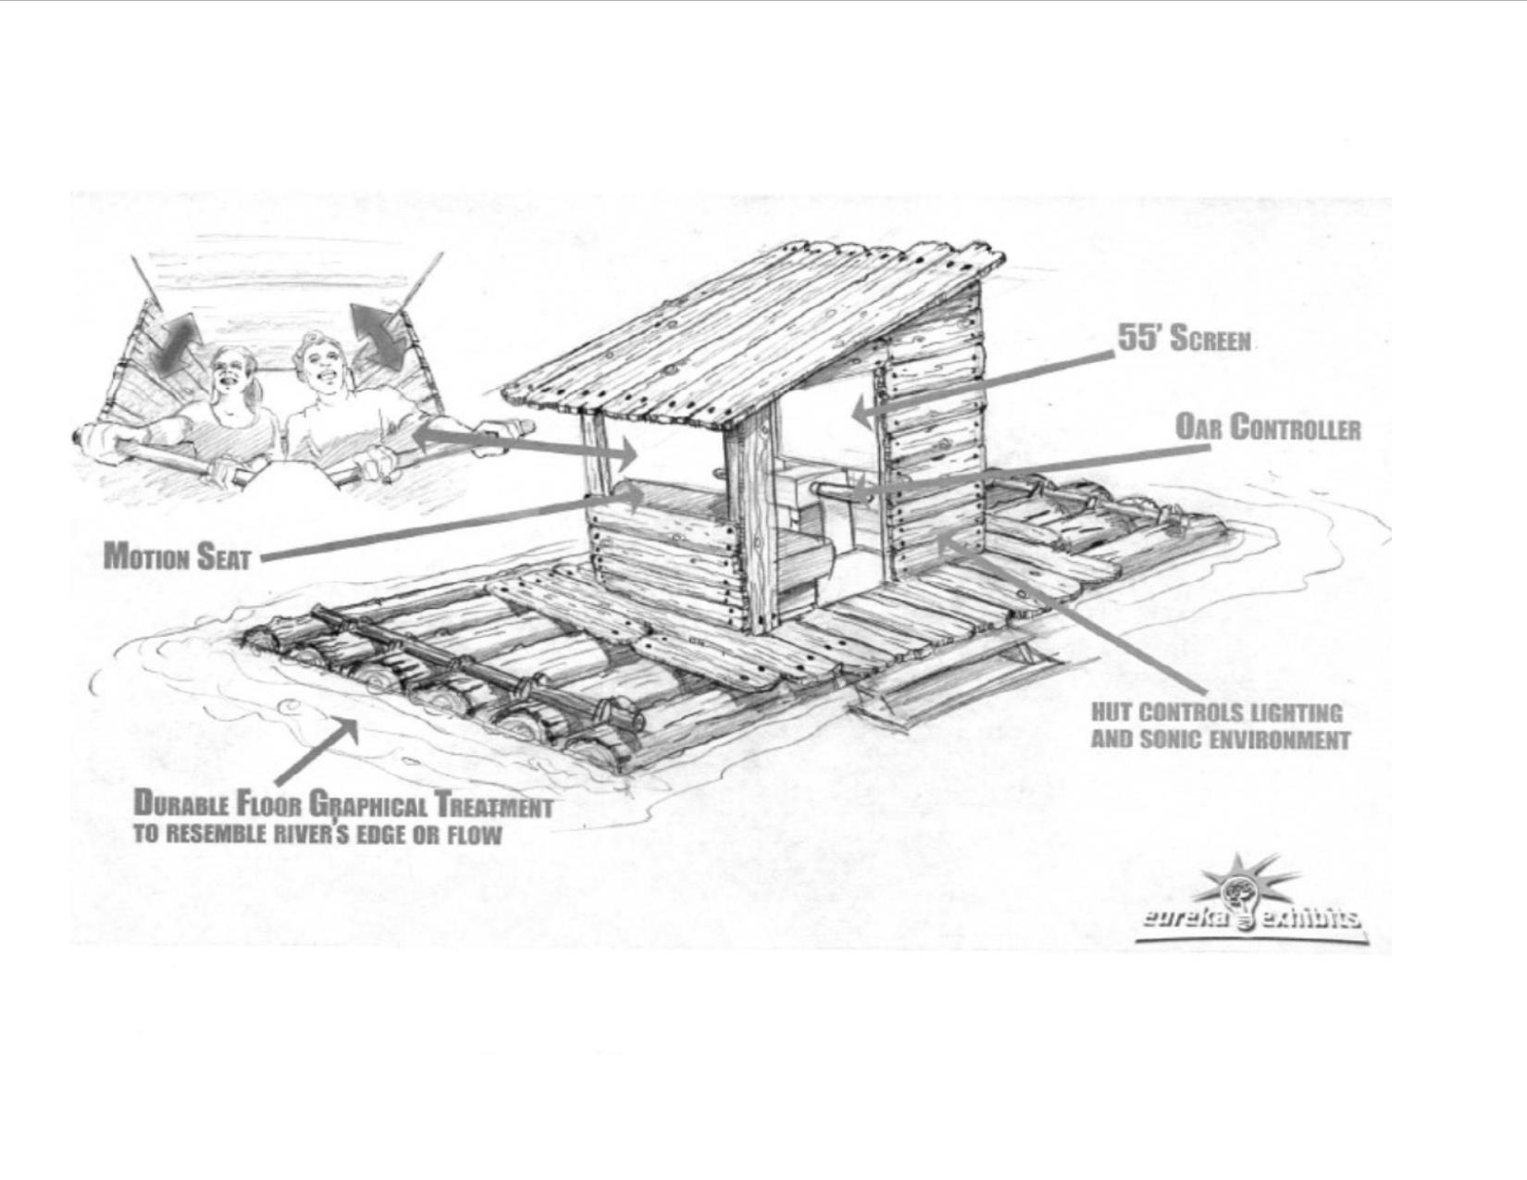 | April & May  All programs are included in regular admission. A membership is a great way to enjoy both programs and the museum.  April 7 10:30-Noon:  Crafts themed around classic kid’s books  April 14 Clinton National Bank Thumbuddies  April 21 10:30-Noon: Crafts to Celebrate Earth Day  April 28 All Day: Boy Scouts History Merit Badge  May 5 10:30-Noon: Star Wars Day: First 25 kids receive a Metal Earth 3D Star Wars model kit.  May 12 10:30-Noon:  Crafts and Activities Relating to Flying: Planes & Kites  May 19 10:30-1pm:  International Museum Day Activities  May 26 : Train Day: A day of train crafts and the museum train will be running for $2 a rider.  All programs included in regular admission to museum  Check out Toddler Thursdays  New Exhibits Coming for 2018!  [Item]  [Phone number]

